

Project Charter <Full Version Template>
<Project Name>
<Branch >


National Project Management System
Business Projects-IT-Enabled
Analysis Phase

This NPMS document template is based on the Treasury Board Project Charter Template.
© Her Majesty the Queen in Right of Canada, represented by the President of the Treasury Board, 2008
Catalogue No. ISBN
This document is available in alternative formats
and on the Treasury Board of Canada Secretariat’s Web site at the following address:
www.tbs-sct.gc.ca

Instructions
This document is your template for producing a project charter, a mandatory National Project Management System (NPMS) deliverable.
Document Purpose
A project charter is, “a document issued by the project initiator or sponsor that formally authorizes the existence of a project, and provides the project manager with the authority to apply organizational resources to project activities.”
The purpose of the charter is to obtain formal approval on the general parameters and structure of the proposed project, including:
- the project objectives and outcomes, benefits, scope, and risks;
- the project deliverables, schedule, milestones, and estimated costs; and
- the project organization, governance structure, and stakeholders.

Using this Template
To create a project charter from this template:
Replace the <bracketed text> on the cover page with the name of your project and the organization’s information.
Replace the <bracketed text> in the document header with your project name and your organization’s information.
Save your document with a file name that is in accordance with NPMS practice.
Update the filename in the document footer by right-clicking and selecting Update Field.
Complete the entire template. Each section contains abbreviated instructions, shown in italics, which can be removed once your document is finalized. Tables are also provided as a suggested layout for some of the information required.
Update the table of contents by right-clicking and selecting Update Field, then update entire table.
You can also use the companion document, “Project Charter Guide,” if you would like more information about a particular section of the charter, or about the project charters in general.
When you have completed your draft project charter, delete this page.

Table of Contents
Section 1. Charter Introduction 3
1.1 Document Change Control 3
1.2 Executive Summary 4
1.3 Authorization 5
Section 2. Project Overview 6
2.1 Project Summary 6
2.1.1 Project Goals, Business Outcomes and Objectives 6
2.1.2 Project Scope 6
2.1.3 Scope Definition 6
2.1.4 Boundaries 6
2.2 Milestones 7
2.3 Deliverables 7
2.4 Project Cost Estimate and Source of Funding 7
2.4.1 Project Cost Estimate 7
2.4.2 Source of Funding 8
2.5 Dependencies 8
2.6 Project Risks, Assumptions, and Constraints 9
2.6.1 Risks 9
2.6.2 Assumptions 9
2.6.3 Constraints 9
Section 3. Project Organization 10
3.1 Project Governance 10
3.2 Project Team Structure 10
3.3 Roles and Responsibilities 10
3.4 Project Facilities and Resources 11
Section 4. Project References 11
Section 5. Glossary and Acronyms 11

- Charter Introduction
  - Document Change Control
<This section serves to control the development and distribution of revisions to the project charter. It should be used in accordance with the recommended PWGSC Information Management process (see the NPMS Business Projects-IT- Enabled Information Management Knowledge Area). It is recommended that changes to the project charter be documented only by adding annexes to the original project charter. This will keep an accurate history of the original document that was first approved.>
Revision Number | Date of Issue | Author(s) | Brief Description of Change
1.0

  - Executive Summary
<Provide a brief summary of the project in business terms, demonstrating alignment with the departmental strategic outcomes and the desired business outcomes that were identified by the participating organization(s) in the business case. Summarize the most important aspects of the project by answering the questions:
  - How and why was the project initiated?
  - Who will use the final deliverable of the project?
  - Who will be impacted by the project?
The following elements are usually covered in the Executive Summary:
- Project goals and objectives
- Major milestones
- Key deliverables
- Key risks
- Estimated total costs.>

  - Authorization
<This section contains the signatures of the key stakeholders, signifying agreement of roles and the description of the project as it appears in the project charter.>
This project charter formally authorizes the existence of the project, <Project Name>, and provides the project manager with the authority to apply organizational resources to project activities described herein. If there is a change in the project scope, the project charter will be updated and submitted for re-approval.

George Campanis______________________________________________________ __________
Full name Date
Project Sponsor
Position, Client Organization

______________________________________________________ _______________________
Full name Date
Project Manager
Position, Your Organization

- Project Overview
  - Project Summary
<This section briefly summarizes the entire project charter, highlighting the significant points of interest to the reader. It includes all of the information required for approval by the key stakeholders. The summary should also include some background information on the project that:
  - includes the reason(s) for creating the project (e.g., a business problem or opportunity, a legal requirement, etc.); and,
  - identifies the key stakeholders who will benefit from the project results.>

Project Goals, Business Outcomes and Objectives
<This section describes project goals and links each of them to related measurable business outcomes that are to be derived from the project goals. Measurement criteria must also be provided to confirm that an objective and desired outcome have been reached.
Keep in mind that goals are high-level statements, project objectives are concrete, and measurement criteria usually confirm if an objective has been met. Business outcomes are results expected at the end of the project.
Add rows as required.>
No. | Goals | Objectives | Business Outcomes
1
2
3

Project Scope
    - Scope Definition
<Provide a high-level description of the features and functions that characterize the product, service, or result that is to be delivered by the project.>

Boundaries
<Expand on the scope definition and outline the major activities required to successfully complete the project (e.g., develop module ABC, develop requirements document, etc.). Out of scope activities are identified to reduce ambiguity.
Add rows as required.
While the table provides a summary view of the project boundaries, further explanations should be provided in a narrative form following the table.>
Activities In Scope | Activities Out of Scope
1. | 1.
2. | 2.
3. | 3.

<Insert additional explanations for project boundaries here.>
  - Milestones
<Identify the significant points or events in the project (e.g., NPMS stages, phases, control point approval gates, etc.). This table can also represent a high-level project schedule.>
Project Milestone | Description | Expected Date
1.
2.
3.
  - Deliverables
<Identify and define what the project must deliver in order to achieve the stated objectives. Include internal project deliverables required by the project management process for review and approval purposes (e.g., project transition plan, communication plan, lessons learned register, etc.).
Determine criteria that will be used to assess the quality and completion of each deliverable.
Indicate stakeholder(s) responsible for approving each deliverable and the deliverable’s due date.
Add rows as required.>
Project Deliverable 1: [Deliverable Name]
Stakeholder:
Description:
Acceptance Criteria:
Due Date:
Project Deliverable 2: [Deliverable Name]
Stakeholder:
Description:
Acceptance Criteria:
Due Date:

<The deliverables section can be used to build the project’s high-level work breakdown structure, breaking the major deliverables into smaller, more manageable parts.>
  - Project Cost Estimate and Source of Funding
    - Project Cost Estimate
<Record cost estimates for all resources (i.e., human, material and financial) required to produce the deliverables and meet the objectives established for the project. To ensure the full project scope is covered, refer to items listed in the initial work breakdown structure and in project effort estimates. Include one-time as well as on-going costs. For example, provide the estimated on-going cost to sustain product(s)/service(s) that are to be produced by the project. Modify the table as required.
The business case for the project should contain cost estimates that can be used as the basis for this summary.>
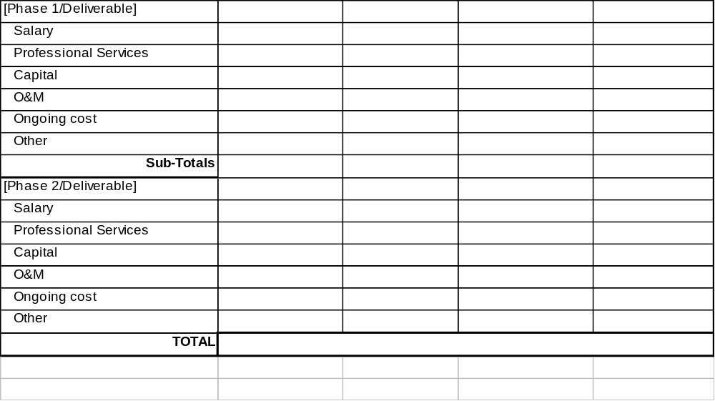

Source of Funding
<State various sources of funding that will be used to support the project. It should be clear to the project sponsor and to the project manager where the funds will come from and that human resources have been committed to this project.>
  - Dependencies
<List project dependencies such as:
- predecessor/successor relationship existing with another project (MOU, partnerships, etc.);
- related projects requiring a deliverable from this project;
- if this project requires a deliverable from a related project; or
- if this project will deliver a product, service or result that needs to be released along with another new product, service, or result.>
Dependency Description | Critical Date | Contact
  - Project Risks, Assumptions, and Constraints

Risks
<This initial risk assessment does not replace the full risk assessment conducted during the planning phase. The following table records strategic risks that have been identified at the start of a project. For each risk, list both the level of impact and the degree of probability (i.e., high, medium, low). Identify the possible responses needed during the project to lessen the impact or lower the probability of the risk, and assign an OPI responsible for resolution. Enter the top five or fewer risks. In accordance with PWGSC Risk Management Procedures, acceptable responses to risk include accepting, transfering, mitigating, or eliminating the risk. >

No. | Risk Description | Probability  (H/M/L) | Impact  (H/M/L) | Risk Management Plan | OPI
1
2
3

Assumptions
<State assumptions that, for planning purposes, are considered to be true, real, or certain. These assumptions will be validated during the planning process. Inaccurate, inconsistent, or incomplete assumptions result in project risks.
Add rows as required.>
The following table lists the items that cannot be proven or demonstrated when this project charter was prepared, but they are taken into account to stabilize the project approach or planning.
No. | Assumptions
1
2
3

Constraints
<Identify the specific constraints or restrictions that limit or place conditions on the project, especially those associated with the project scope (e.g., a hard deadline, a predetermined budget, a set milestone, contract provisions, privacy or security considerations, etc.). Categorize the constraints if there are several.
Add rows as required.>
The following table lists the conditional factors within which the project must operate or fit.
No. | Category | Constraints
1
2
3

- Project Organization
  - Project Governance
<Describe how the project will be governed and identify the corporate governance bodies that may be involved in the approval process. In other words, show how decisions are made and who makes which decisions.
A diagram should be used. If committees are shown in the diagram, the project is to include a description of these committees in the Roles and Responsibilities section.>
  - Project Team Structure
<Use an organizational chart to show the structure of the project team as well as the relationships between team members.
Illustrate how the team interacts with, or relates to, the governance structure for the project.
For small projects, roles of team members can be included; for larger projects, the organizational chart should name the groups or entities that form the project teams.>
  - Roles and Responsibilities
<Define the roles and responsibilities assigned to each member of the project team as well as those of any stakeholders and working groups that have a significant influence on the project.
Include all committees and entities identified in the sections 3.1 - Project Governance and section 3.2 - Project Team Structure.>
Project Role | Responsibilities | Assigned to
[Project Manager]
[Business Analyst]
[Project Review Committee]

  - Project Facilities and Resources
<Describe, if applicable, the project's requirements for facilities and resources, such as office space, special facilities, computer equipment, office equipment, and support tools.
Identify the person or team responsible for obtaining the specific items needed to support the project’s development environment.>
- Project References
<In this section, identify and describe the location of the key documents that define and establish the project such as the business case, the departmental investment plan, departmental long-term strategy, outcome management plan, outcome map, Speech From the Throne, Cabinet directions, horizontal government initiatives, etc.>
More information concerning this project can be found in the following documents:
Document Title | Version # | Date | Author and Organization | Location (link or path)
Project Charter Guide | 1D | 20-Mar-2008 | Chief Information Officer Branch (CIOB) | Y:\CIOB\Template
- Glossary and Acronyms
<Define all terms and acronyms required to interpret the project charter properly.>
Term | Definition
Acronym | Name in Full

Checklist for reviewing your project charter:
After you have completed filling in the template for your project charter, use the list below to review the different sections to make sure you have included all the information required.

- The executive summary demonstrates a clear alignment between the project, the Departmental Investment Plan, and the Program Activity Architecture.
- There are specific and measurable project objectives and business outcomes that are linked to project goals.
- The scope of the project is clearly stated; the reader can easily understand what product, service, or result will be delivered by the project and what high-level activities will be performed.
- The deliverables are spread over the duration of the project, following a phased approach composed of decision gates.
- Summary cost estimates and source of funding to produce internal and external deliverables are provided, including the project management and administrative effort as well as any equipment required (e.g., hardware, software, floor space, etc.).
- Strategic risks are identified and assessed.
- A governance process is defined to escalate issues when required, to approve changes to the project (e.g., scope, budget, schedule), and to accept deliverables.
- Authority relationships between team members are clearly presented.
- Project roles and responsibilities are defined and assigned to individuals or groups.
- Requirements for facilities and resources are described where significant logistical effort or funding is involved.
If all of these are checked as complete, then delete this checklist, update the Table of Contents, and save the document to file.

A Guide to the Project Management Body of Knowledge (PMBOK® Guide) Third Edition, p. 368.

